**User Guide:**

**1. Download the raw data file: SmallAreaIncomePovertyEstData.txt**

**2. Run Assignment10PartA**

**3. Enter input and output file location (please see below for reference)**

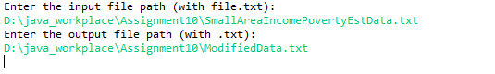

**4. Confirm output file (i.e. modified data file) is generated correctly as below**

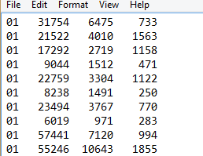

**5. Run Assignment10PartB**

**6. Enter file location for the output file generated by Assignment10PartB (see below for** reference)



**7. Final report should be displayed now as below**

